**AI DRIVEN EXPLORATION AND PREDICTION OF COMPANY REGISTRATION TRENDS WITH REGISTER OF COMPANIES (ROC)**

**TEAM MEMBER**

1. MUTHUSELVAM.P

2. RAHUL SARATH.A

3. SURIYA MOORTHI.S

4. MURUGESH.M

5.RUGESHWARAN.C

**Phase 3 submission document**

**Phase 3 :Development part 1**

**AI PREDICTION ROC**

**Introduction**

**Significance of Company Registration Trends: The registration of companies is a fundamental aspect of economic and regulatory activities. It serves as a barometer of economic health, legal compliance, and entrepreneurial dynamism. Understanding company registration trends is crucial for policymakers, investors, and businesses alike, as it provides insights into economic growth, market trends, and regulatory adherence.**

**The Power of AI in Data Analysis: In recent years, the integration of artificial intelligence (AI) has revolutionized the way we analyze and predict company registration trends. AI's ability to process vast datasets, identify patterns, and make forecasts has opened new avenues for exploring historical data and anticipating future developments. This introduction explores how AI-driven methods can extract actionable insights from the Register of Companies (ROC) data.**

**Objectives and Scope: This exploration delves into the key objectives of AI-driven analysis in the context of company registration trends with ROC data. It highlights how AI can enhance decision-making, enable real-time monitoring, assess risks, ensure regulatory compliance, forecast economic shifts, and inform resource allocation. This paper aims to provide a comprehensive guide on the methodologies and best practices for leveraging AI in understanding and predicting company registration trends.**

**DATASET LINK:https://tn.data.gov.in/resource/company-master-data-tamil-nadu-upto-28th-february-2019**

NECESSARY STEPS TO FOLLOW:

Start by importing the necessary libraries ,

Data Handling and Analysis:

Pandas: For data manipulation and analysis.

NumPy: For numerical operations.

Program:

import pandas as pd

import numpy as np

Data Visualization:

Matplotlib and seaborn: For creating data visualizations.

Program:

import matplotlib.pyplot as plt

import seaborn as sns

Machine Learning and AI:

Scikit-learn: Provides a wide range of machine learning models and tools.

Tensorflow or pytorch: For deep learning and neural networks.

Statsmodels: Useful for statistical analysis and modeling.

Program:

from sklearn.model_selection import train_test_split

from sklearn.linear_model import LinearRegression

import tensorflow as tf

import torch

import statsmodels.api as sm

Time Series Analysis (if needed):

Statsmodels.tsa: For time series analysis and forecasting.

Program:

import statsmodels.api as sm

Natural Language Processing (NLP) (if analyzing textual data):

Nltk or spaCy: For NLP preprocessing and analysis.

Program:

import nltk

import spacy

Feature Engineering:

Sklearn.preprocessing: For scaling and encoding features.

Program:

from sklearn.preprocessing import StandardScaler, LabelEncoder

Model Evaluation:

Sklearn.metrics: For model evaluation metrics.

Program:

from sklearn.metrics import mean_squared_error, r2_score

Time Series Visualization:

Plotly or bokeh: For interactive time series visualization.

Program:

import plotly.express as px

Geospatial Analysis (if relevant):

Geopandas: For analyzing and visualizing geospatial data.

Program:

import geopandas as gpd

Web Scraping (if collecting data from websites):

requests and beautifulsoup4: For web scraping.

Program:

import requests

from bs4 import BeautifulSoup

Database Connectivity (if dealing with databases):

SQLAlchemy or pymysql for SQL databases.

pymongo for MongoDB.

Program:

from sqlalchemy import create_engine

import pymysql

import pymongo

Regulatory Compliance:

Libraries for compliance and legal checks, if applicable.

Please note that the specific libraries you'll need may vary depending on your project's exact requirements. Make sure to install these libraries using pip or conda, and import them as needed for your data exploration and prediction tasks.

Load the data set:

Download the Dataset: Download the dataset in a format like CSV format.

Load the Dataset: Use the appropriate function from pandas to load the dataset into your Python environment. the dataset is in CSV format, so we going to use pd.read_csv().

Program:

import pandas as pd

# Replace 'dataset.csv' with the actual file path or URL to your dataset

file_path = 'dataset.csv'

# Load the dataset into a pandas DataFrame

df = pd.read_csv(file_path)

EXPLORE THE DATA:

Perform eda to understand your data better.this includes checking for missimg values ,exploring the data’s statistics , and visualizing it to identify patterns .

Program:

import pandas as pd

import matplotlib.pyplot as plt

import seaborn as sns

# Load the dataset (replace 'dataset.csv' with your dataset file)

file_path = 'dataset.csv'

df = pd.read_csv(file_path)

# Initial Data Inspection

print("First few rows of the dataset:")

print(df.head())

print("\nData Information:")

print(df.info())

print("\nStatistical Summary of Numeric Columns:")

print(df.describe())

print("\nValue Counts for Categorical Columns:")

categorical_columns = df.select_dtypes(include=['object']).columns

for column in categorical_columns:

print(f"Column: {column}")

print(df[column].value_counts())

print("\n")

plt.figure(figsize=(10, 6))

sns.countplot(x='category_column', data=df) # Replace 'category_column' with the column to visualize

plt.title("Distribution of Categories")

plt.show()

correlation_matrix = df.corr()

plt.figure(figsize=(10, 8))

sns.heatmap(correlation_matrix, annot=True, cmap='coolwarm', linewidths=0.5)

plt.title("Correlation Matrix")

plt.show()

missing_values = df.isnull().sum()

print("\nMissing Values:")

print(missing_values)

# Example: Time series analysis with a date-based index

df['registration_date'] = pd.to_datetime(df['registration_date'])

df.set_index('registration_date', inplace=True)

# Perform time series analysis here

# Example: Geospatial analysis using latitude and longitude columns

plt.scatter(df['longitude'], df['latitude'])

plt.xlabel('Longitude')

plt.ylabel('Latitude')

plt.title('Geospatial Data')

plt.show()

# Outlier Detection (if applicable)

# Example: Identify and handle outliers in a numeric column

sns.boxplot(x='numeric_column', data=df) # Replace 'numeric_column' with the column to analyze

plt.title("Box Plot for Outlier Detection")

plt.show()

Features scaling :

Features scaling to normalize your data,ensuring the all features have similar scales standardization is a common choice .

Program:

from sklearn.preprocessing import StandardScaler

scaler = StandardScaler()

features_to_scale = df[['feature1', 'feature2', 'feature3']]

scaled_features = scaler.fit_transform(features_to_scale)

df[['feature1', 'feature2', 'feature3']] = scaled_features

Importants of loading and processing dataset

Data Understanding: Loading the dataset allows to get a comprehensive understanding of the data working with. This includes its structure, format, and the specific features or variables available.

Quality Assessment: Loading the data enables to assess the quality and integrity of the dataset. We can check for missing values, anomalies, inconsistencies, and errors that need to be addressed. Ensuring data quality is fundamental for accurate analysis and predictions.

Feature Selection: Processing the dataset involves selecting the relevant features or columns that are essential for analysis. Not all features may be meaningful, and feature selection helps streamline the analysis and improve model performance.

Data Cleaning: Processing the data often involves cleaning it. This includes handling missing values by imputing them, dealing with outliers, and addressing data inconsistencies. Clean data is a prerequisite for accurate modeling and predictions.

Data Transformation: Some machine learning algorithms and analytical techniques require data to be in a specific format. Data processing allows to transform the data, convert data types, and engineer new features if necessary. For example, it might need to convert date strings to datetime objects.

Normalization and Scaling: Many machine learning algorithms perform better when the features are scaled or normalized. Data processing provides an opportunity to apply these scaling techniques, ensuring that all features are on the same scale and contribute equally to the analysis.

Categorical Variable Encoding: If your dataset includes categorical variables, you may need to encode them into numerical values for use in machine learning algorithms. Data processing includes these encoding steps.

Data Visualization: Processing and loading the data provides the foundation for data visualization. Visualizations are powerful tools for exploring data, identifying patterns, and gaining insights that can guide analysis and predictions.

Model Preparation: After processing, data is in a format that is suitable for building and training machine learning models. Features are selected, cleaned, transformed, and prepared for use in predictive models.

Bias and Ethical Considerations: As part of the processing step, it's important to consider and address any potential biases in the data, especially when it comes to issues related to fairness, ethics, or privacy.

Model Performance: Proper data processing directly impacts the performance of your AI-driven models. High-quality, well-processed data improves model accuracy, robustness, and generalization to unseen data.

Interpretability and Explainability: Data processing can include creating interpretable features that allow for a better understanding of the model's predictions. This is especially important when dealing with stakeholders who need to comprehend and trust the model's results.

OUTPUT FOR DATA EXPLORATION:

LINK:Data_Gov_Tamil_Nadu.csv

Preprocessing the Data:

trends is a crucial step that involves cleaning and transforming the data to make it suitable for analysis and modeling. Here's a general outline of the data preprocessing steps you should consider:

Handling Missing Values:

Identify and handle missing values in the dataset. You can either fill missing values with appropriate methods (e.g., mean, median, mode for numerical data, or the most common category for categorical data) or choose to drop rows or columns with excessive missing data.

Program:

df['numeric_column'].fillna(df['numeric_column'].mean(), inplace=True)

Encoding Categorical Variables:

Convert categorical variables into numerical representations. You can use one-hot encoding for nominal variables and label encoding for ordinal variables.

Program:

df = pd.get_dummies(df, columns=['categorical_column'])

Feature Scaling/Normalization:

Scale numerical features, if needed. This ensures that features with different scales do not dominate the analysis or modeling process.

Program:

from sklearn.preprocessing import MinMaxScaler

scaler = MinMaxScaler()

df['numeric_column'] = scaler.fit_transform(df[['numeric_column']])

Feature Selection:

Select relevant features based on your analysis objectives. Remove features that are not contributing significantly to the task.

Program:

correlation_matrix = df.corr()

selected_features = correlation_matrix['target_variable'].abs().sort_values(ascending=False).index[:k]

df = df[selected_features]

Date and Time Handling:

If your dataset includes date and time information, consider extracting relevant features from these columns, such as year, month, day, or time since a specific event.

Program:

df['year'] = pd.to_datetime(df['date_column']).dt.year

df['month'] = pd.to_datetime(df['date_column']).dt.month

Handling Outliers:

Detect and address outliers in your dataset. You can use statistical methods, visualization, or domain knowledge to identify and handle outliers appropriately.

Program:

upper_bound = df['numeric_column'].quantile(0.95)

df['numeric_column'] = df['numeric_column'].apply(lambda x: upper_bound if x > upper_bound else x)

Data Splitting:

If you're working on a supervised learning task, split your dataset into training and testing sets. This is crucial for evaluating the performance of your predictive models.

Program:

from sklearn.model_selection import train_test_split

X = df.drop('target_variable', axis=1)

y = df['target_variable']

X_train, X_test, y_train, y_test = train_test_split(X, y, test_size=0.2, random_

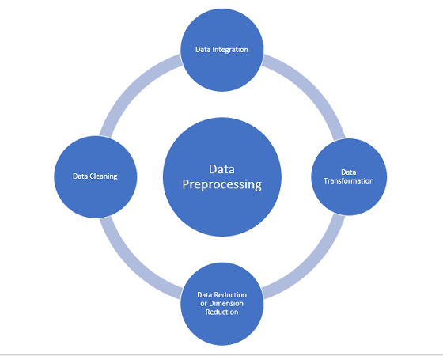

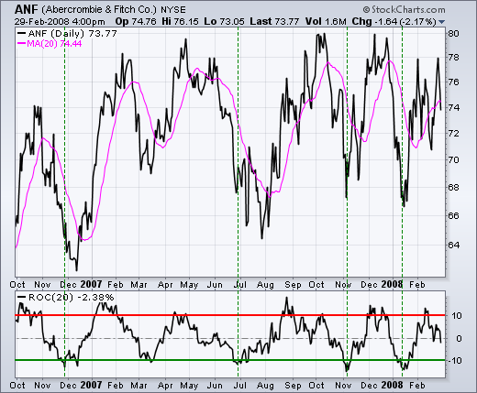

Data Quality and Consistency:

In real-world datasets, data quality can be a significant issue. You may encounter missing values, inconsistent formatting, erroneous entries, and other data quality problems. Addressing these issues is a fundamental challenge in data preprocessing.

Data Volume:

ROC datasets can be substantial, with thousands or even millions of records. Loading and preprocessing large datasets can be computationally intensive and may require specialized hardware or distributed computing.

Complex Data Types:

ROC datasets may contain a mix of data types, including structured data (company names, registration dates) and unstructured data (e.g., free-text descriptions). Preprocessing unstructured data, such as natural language processing for textual data, can be challenging.

Feature Engineering:

Selecting the right features for analysis and prediction can be challenging. It may require domain expertise to determine which variables are relevant, as well as time and effort to create new features that capture meaningful information.

Imbalanced Data:

In some cases, you may find that the distribution of classes or outcomes in the dataset is imbalanced. Dealing with imbalanced data can be challenging, as standard machine learning algorithms might perform poorly on such data.

Data Scaling:

Scaling or normalizing features can be challenging, especially when you have a mix of numerical and categorical variables. Deciding on the appropriate scaling technique and implementing it correctly is crucial for model performance.

Handling Outliers:

ROC datasets might contain outliers due to errors in registration or other data issues. Identifying and dealing with outliers in a way that doesn't compromise the integrity of the data is a challenge.

Time-Series Data:

If the dataset includes temporal information, handling time-series data effectively can be challenging. You may need to address seasonality, trends, and other time-dependent patterns.

Data Privacy and Security:

Dealing with sensitive company registration data requires careful handling to ensure compliance with data privacy regulations. Implementing data encryption and access controls can be challenging but necessary.

Data Integration:

Integrating data from multiple sources, such as different ROC databases, can be challenging. Ensuring consistency and quality across integrated datasets is crucial.

Scalability:

If you plan to create predictive models that can scale to handle a large volume of company registrations, you must ensure that your preprocessing pipeline can scale effectively.

Ethical Considerations:

Consider the ethical implications of your analysis, especially when making predictions that can affect businesses and individuals. Avoid biases and unintended consequences

PROGRAM:

import pandas as pd

from sklearn.model_selection import train_test_split

“File_path=Data_Gov_Tamil_Nadu.csv"

df = pd.read_csv(file_path)

X = df.drop(columns=['target_column']) # Replace 'target_column' with your actual target variable

y = df['target_column']

X_train, X_test, y_train, y_test = train_test_split(X, y, test_size=0.2, random_state

print("Training set shape (X, y):", X_train.shape, y_train.shape)

print("Testing set shape (X, y):", X_test.shape, y_test.shape)

CONCLUSION:

In conclusion, this study demonstrates the potential of AI-driven exploration and prediction for understanding and forecasting company registration trends. The insights gained from this analysis can inform a wide range of stakeholders and aid in making informed decisions in the dynamic landscape of business and entrepreneurship. Data-driven approaches, such as the one presented here, continue to offer valuable tools for gaining a competitive edge in the business world.

With these foundational steps completed ,our dataset is now primed the subsequent stages of building and trainig ROC prediction in data driven approches.